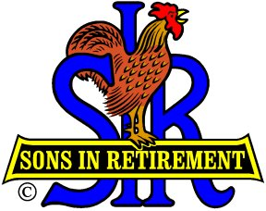
SIR Branch 116 Activities
Please visit our Website at http://branch116.org to see details for all of the following activities.
- Monthly Luncheon with Guest Speaker (no lunch in May or December)
- Book Club – Read and discuss books
- Book Exchange – Exchange books at monthly luncheon
- Bridge – Meet at Roundhill Country Club twice a month
- Duplicate Bridge – Meet at Pleasant Hill Bridge Center once a month
- Computers & Technology – Meet at WC Elks Lodge on 3rd Thursday of month
- Fishing – Variety of events with monthly meeting at Diablo Creek Golf Course
- Golf – 18 Hole – Play golf every Monday at a variety of courses (some private Country Clubs)
- Golf – 9 Hole – Play golf every Wednesday at public courses
- Mexican Train – Meet on 2nd Wednesday of the month
- Poker (small stakes) – Play at Diablo Country Club following SIR luncheon.
- Finance & Investments – Hear guest speakers on financial topics. Meet at Diablo Creek Golf course on 4th Wednesday of month.
Couples Activities
  - Amblers – Short walks and socializing on 2nd & 4th Fridays each month.
  - Dine Out – 5 events each year at special restaurants.
  - Travel – SIR travel offers opportunities throughout the world to travel with fellow SIR members.
  - Walking Tours – Several times a year an interesting venue is offered in the Bay Area.
  - Wine Appreciation – Meet in one another’s homes to sample wines and socialize

