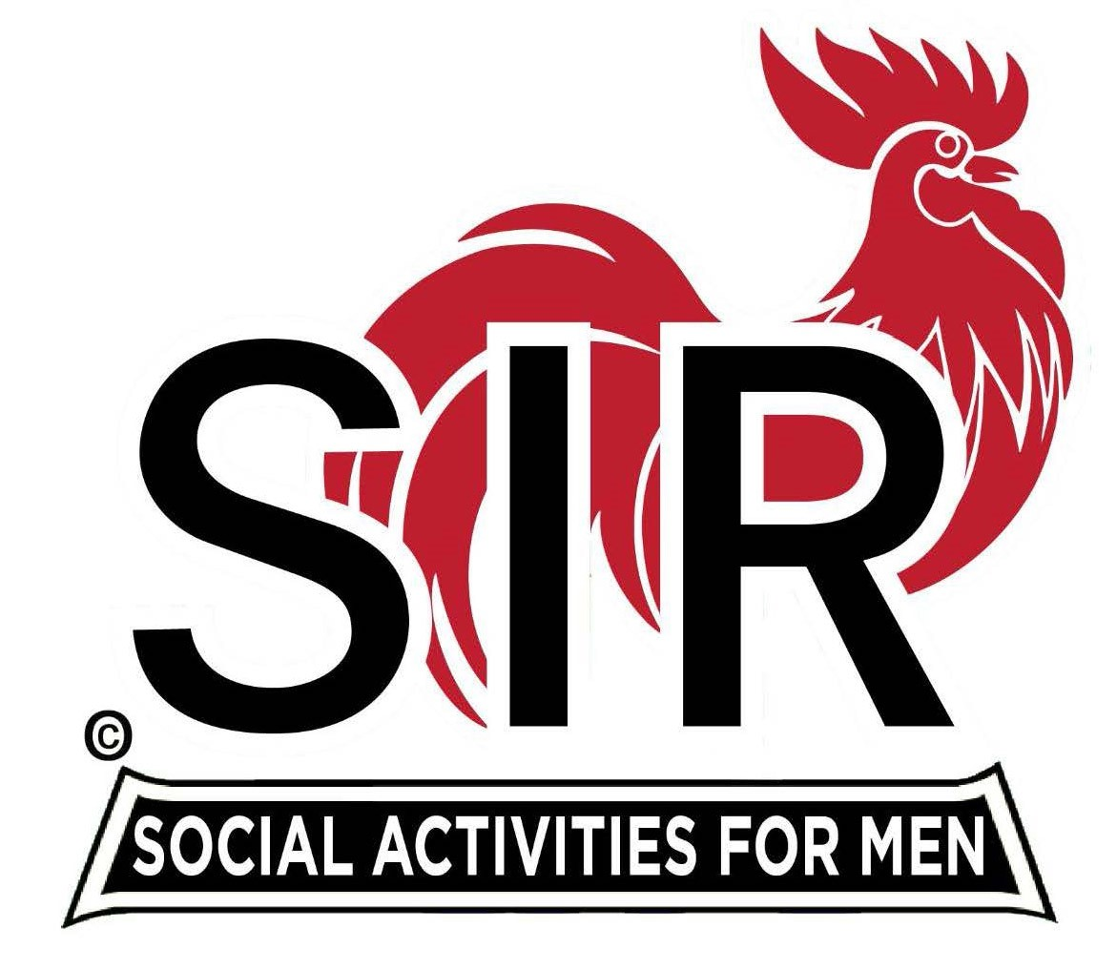
Las Trampas Branch 116
BEC Meeting Agenda
March 16, 2026 - 9:15 AM at Boundary Oak
The Mission of SIR is to enhance the lives of our members through fun activities, events and luncheons while making friends for life.

09:15 | Call to order – Brad Stribling  - Secretary – Paul Ramocciotti  - Confirm quorum  - Approval of February 16, 2026 BEC Meeting Minutes
09:20 | Standing Reports  - Treasurer Report – Charlie Guthrie  - Treasury Report  - Luncheon Count – Eric Linak  - Big SIR Report – Brad Stribling  - Two new members - see the Luncheon Agenda  - Membership – Phil Goff  - RAMP Department Head Reports  - Recruitment – Jeff Johnson  - Activity Coordinator – still need a nominee  - Member Relations – Sam Beret (will be absent - still need a replacement nominee)  - Publicity – Al Farbman
9:50 | Little SIR Updates – Dan Lawrence  - Speaker Info – Today’s speaker – Brian Copeland  - will be introduced at Luncheon by Brad Stribling  - Birthday Boys – March
9:55 | Updates & New Business  - About ‘Made it to 90’ recognitions  - Vote on acceptance of Officer resignation  - An introduction - Jim Grant by Dan Lawrence  - Vote on a new BEC Officer  - Guests: Two guests this month – see Luncheon Agenda  - Survey regarding Buffet  - Discussion about Spring Fling
10:15 | Adjourn: – Next meeting, April 20th, 2026

