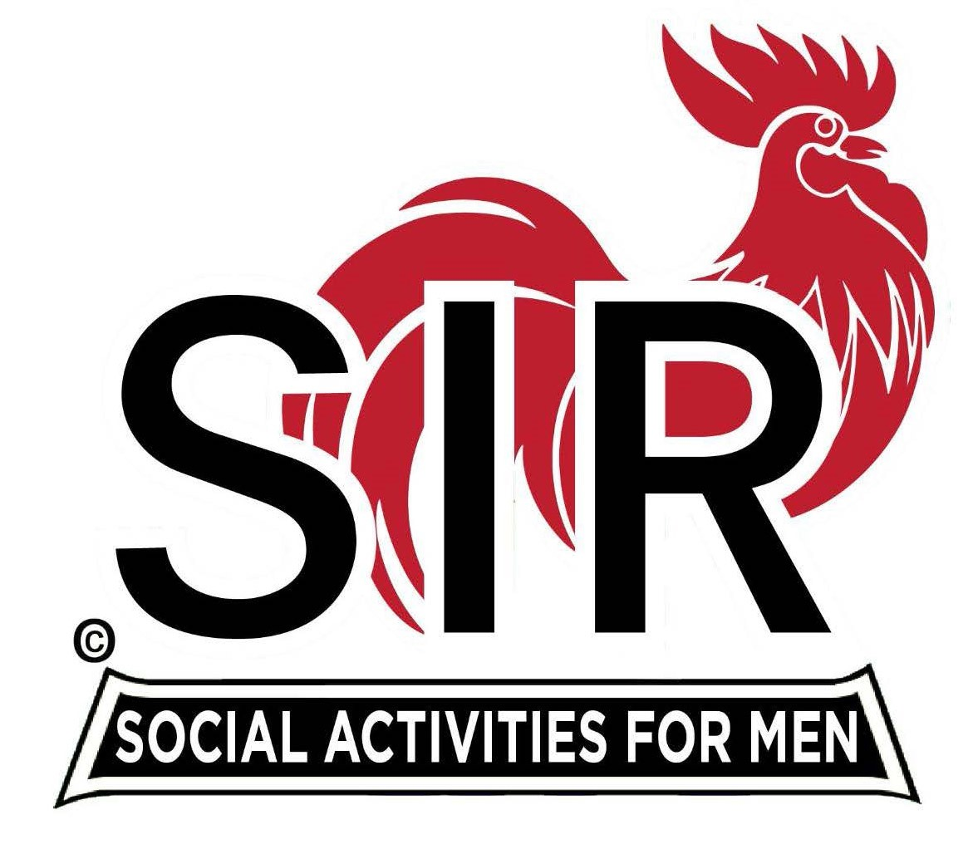
Las Trampas Branch 116
BEC Meeting Agenda - DRAFT
February 16, 2026 - 9:15 AM at Boundary Oak
The Mission of SIR is to enhance the lives of our members through fun activities, events and luncheons while making friends for life.

09:15 | Call to order – Brad Stribling  - Secretary – Tim Tinnes  - Confirm quorum  - Approval of January 19, 2026 BEC Meeting Minutes
09:20 | Standing Reports  - Treasurer Report – Charlie Guthrie  - Treasury Report  - Luncheon Count – Eric Linak  - Big SIR Report – Brad Stribling  - New Members this Month:  - Four this month – see Luncheon Agenda  - Membership – Phil Goff  - RAMP Department Head Reports  - Recruitment – Jeff Johnson  - Activity Coordinator – still need a nominee  - Member Relations – Sam Beret  - Publicity – Al Farbman
9:50 | Little SIR Updates – Dan Lawrence  - Speaker Info – Today’s speaker – Dave Smith  - will be introduced at Luncheon by Dan Lawrence  - Post 90 Recognition - Dick Socolich  - Birthday Boys – February
9:55 | Updates & New Business  - Audit Report - Ron Armijo  - Guests: Five this month – see Luncheon Agenda  - Discussion about Luncheon seating - Allan Farbman and Sam Beret  - Remembrances  - T-Coil System  - Remember - today is a Buffet! Let’s see how we like it.
10:15 | Adjourn: – Next meeting, March 16th, 2026

