In Memory
Sons in Retirement Branch 116 wishes to express our deepest sorrow in the passing of:
Art D. Shingleton
Les was more than just a member of SIR but a friend to all as well as an active participant in many our activities.
Les will be greatly missed.

Arthur Vogl 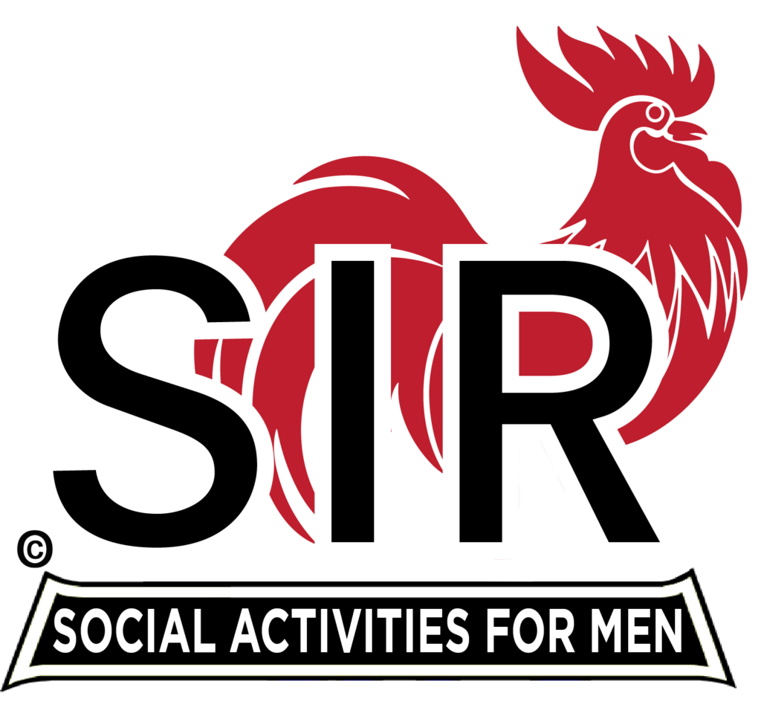
2013 Big SIR, Branch 116

