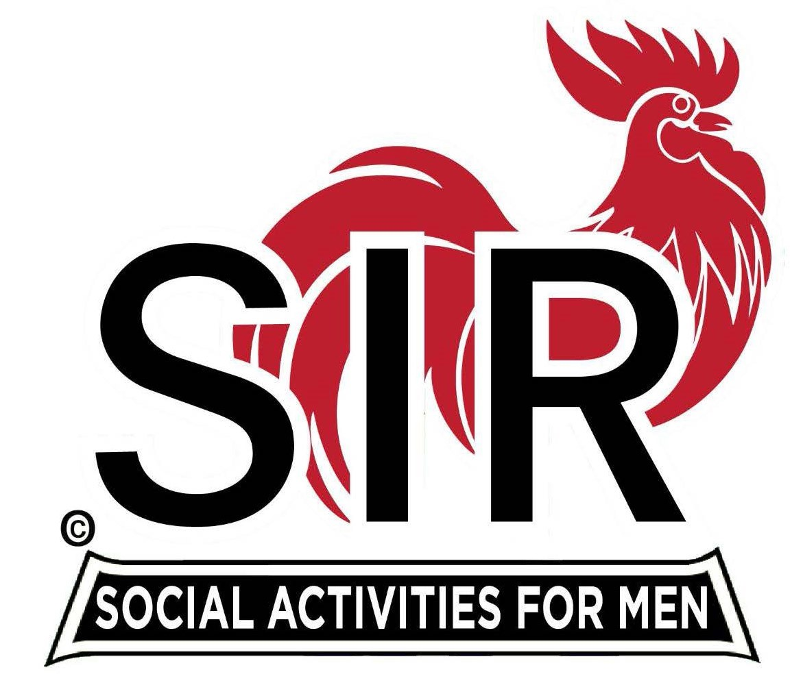
Las Trampas Branch 116
BEC Meeting Agenda
September 15th - 9:15 AM at Boundary Oak
The Mission of SIR is to enhance the lives of our members through fun activities, events and luncheons while making friends for life.

09:15 | Call to order – Paul Russell  - Secretary - Dan Lawrence  - Confirm quorum  - Approval of August 18th, 2025 BEC Meeting Minutes
09:20 | Standing Reports  - Treasurer Report – Charlie Guthrie  - Treasury Report  - Luncheon Count – Eric Linak  - Big SIR Report – Paul Russell  - No New Members this Month  - Membership – Phil Goff  - RAMP Department Head Reports  - Recruitment – Tending to Family  - Activity Coordinator – Mike Ward  - Member Relations – Out of Town  - Publicity – Allen Farbman
9:50 | Little SIR Updates – Brad Stribling  - Speaker Info – Today’s speaker – Mr. Steven Biggs - short Bio  - Birthday Boys – September
9:55 | Updates & New Business  - Guests:  - Kevin Kaster – Guest of Ku Lee  - Carmel Golf Trip (5 min), USS Potomac (5 min)  - Required luncheons for members? Is this going to be a long term issue? Do we have any discussion and could we have a motion and second to vote on this?
10:15 | Adjourn: – Next meeting, October 20th, 2025  - Preparations - Lunch

