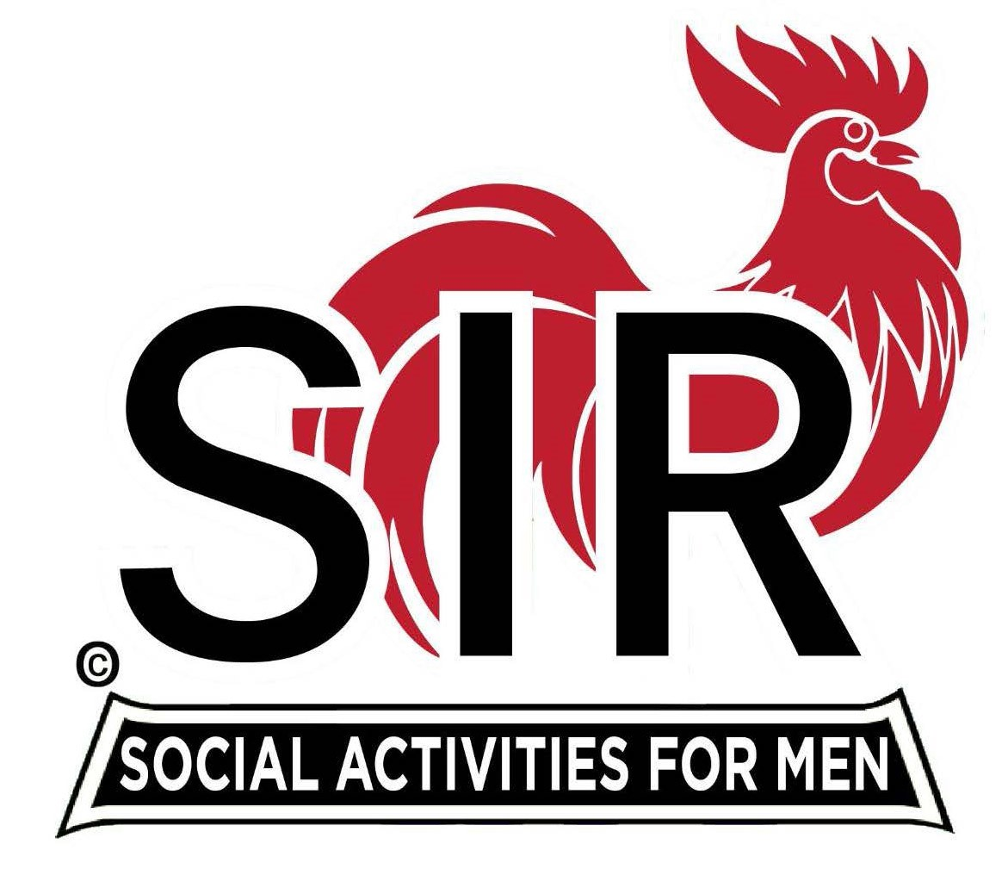
Las Trampas Branch 116
BEC Meeting Agenda
October 20, 2025 - 9:15 AM at Boundary Oak
The Mission of SIR is to enhance the lives of our members through fun activities, events and luncheons while making friends for life.

09:15 | Call to order – Brad Stribling  - Secretary – Paul Ramaccotti for Dan Lawrence  - Confirm quorum  - Approval of September 15th 2025 BEC Meeting Minutes
09:20 | Standing Reports  - Treasurer Report – Charlie Guthrie  - Treasury Report  - Luncheon Count – Eric Linak  - Big SIR Report – Brad Stribling for Paul Russell  - New Members this Month:  - Kevin Kaster sponsored by Ku Lee  - Ron Maslowski sponsored by Neil Schmidt  - Membership – Phil Goff  - RAMP Department Head Reports  - Recruitment – Jeff Johnson  - Activity Coordinator – Mike Ward  - Member Relations – Sam Beret  - Publicity – Al Farbman
9:50 | Little SIR Updates – Brad Stribling  - Speaker Info – Today’s speaker – Kim Grandfield  - will be introduced in Luncheon by Paul Freitas  - Birthday Boys – October
9:55 | Updates & New Business  - Guests:  - Bill Dastic sponsored by Jerry Ricker  - Discussion with B.O. re food quality  - Pending meeting with other branches re same  - How best to handle non-eaters  - Holiday Party  - Welcome and Honor to our Former BIG SIRs !
10:15 | Adjourn: – Next meeting, November 17th, 2025  - Preparations - Lunch

