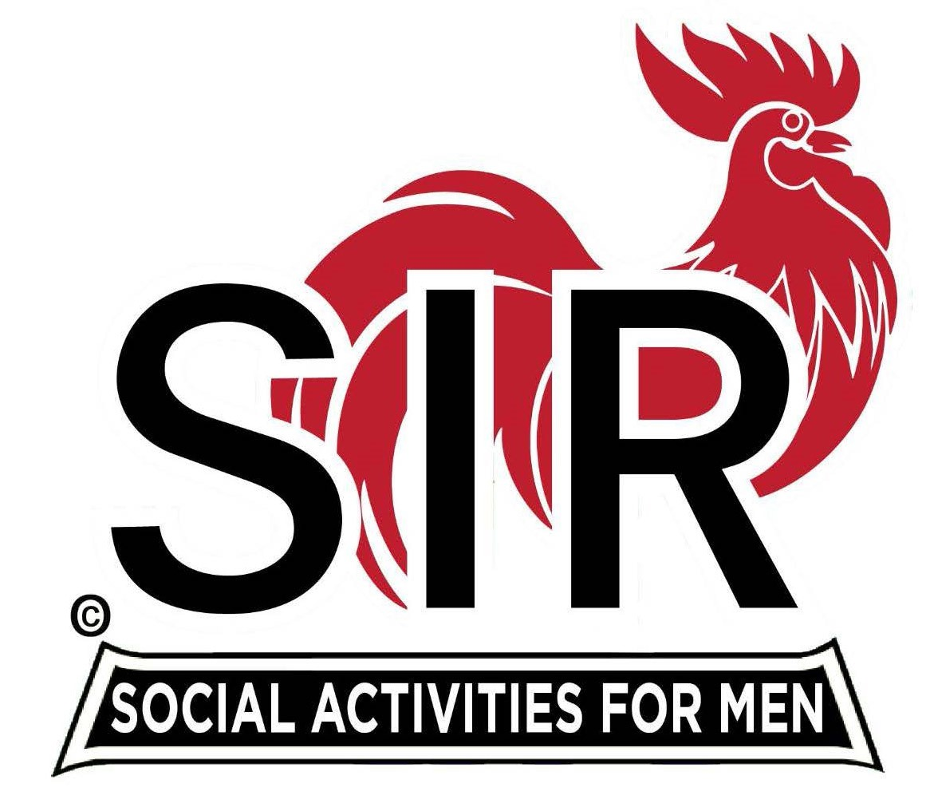
Las Trampas Branch 116
BEC Meeting Agenda
June 16, 2025 - 9:15 AM at Boundary Oak
The Mission of SIR is to enhance the lives of our members through fun activities, events and luncheons while making friends for life.

09:15 | Call to order – Paul Russell  - Secretary - Dan Lawrence  - Confirm quorum  - Approval of April 21, 2025 BEC Meeting Minutes
09:20 | Standing Reports  - Treasurer Report – Charlie Guthrie  - Treasury Report  - Luncheon Count  - Big SIR Report – Paul Russell  - Branch Advisory Council – Carlos Xavier – no update this month  - Membership – Phil Goff  - RAMP Department Head Reports  - Recruitment – Jeff Johnson  - Activity Coordinator – Mike Ward  - Member Relations – Sam Beret – no report this month  - Publicity – Allan Farbman
9:45 | Little SIR Updates – Brad Stribling  - Speaker Info – Today’s speaker – David Bushnell, short Bio  - Birthday Boys – May and June
9:55 | Updates & New Business  - Guests:  - Tom Mackinson – sponsored by Jim Tamulski  - Mike Sherman – sponsored by Jim Tamulski  - Call for Questions
10:15 | Adjourn: – Next meeting, July 21, 2025  - Lunch Preparations

