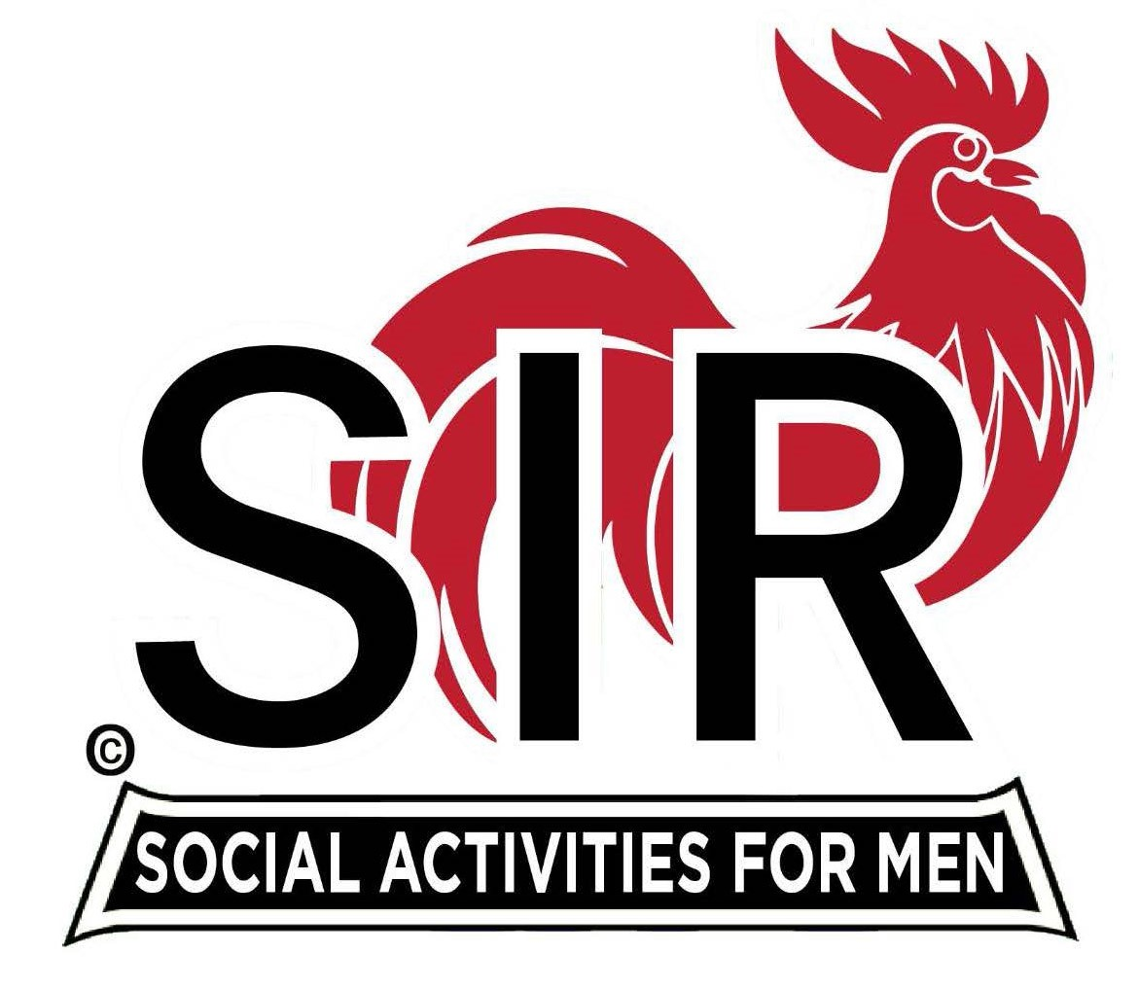
Las Trampas Branch 116
BEC Meeting Agenda
July 21st, 2025 - 9:15 AM at Boundary Oak
The Mission of SIR is to enhance the lives of our members through fun activities, events and luncheons while making friends for life.

09:15 | Call to order – Paul Russell  - Secretary - Dan Lawrence  - Confirm quorum  - Approval of June 16th 2025 BEC Meeting Minutes
09:20 | Standing Reports  - Treasurer Report – Charlie Guthrie  - Treasury Report  - Luncheon Count  - Big SIR Report – Paul Russell  - No New Members this Month  - Branch Advisory Council – Carlos Xavier  - Membership – Phil Goff  - RAMP Department Head Reports  - Recruitment – tending to family  - Activity Coordinator – Mike Ward  - Member Relations – Sam Beret  - Publicity – on vacation
9:50 | Little SIR Updates – Brad Stribling  - Speaker Info – Today’s speaker – Allan Shields, short Bio  - Birthday Boys – July
9:55 | Updates & New Business  - Guests:  - Ku Lee sponsored by – Frank Portillo  - Nomination Committee (10 – 15 min)  - Carmel Golf Trip (5 min), USS Potomac (5 min)
10:15 | Adjourn: – Next meeting, August 18th, 2025  - Preparations - Lunch

