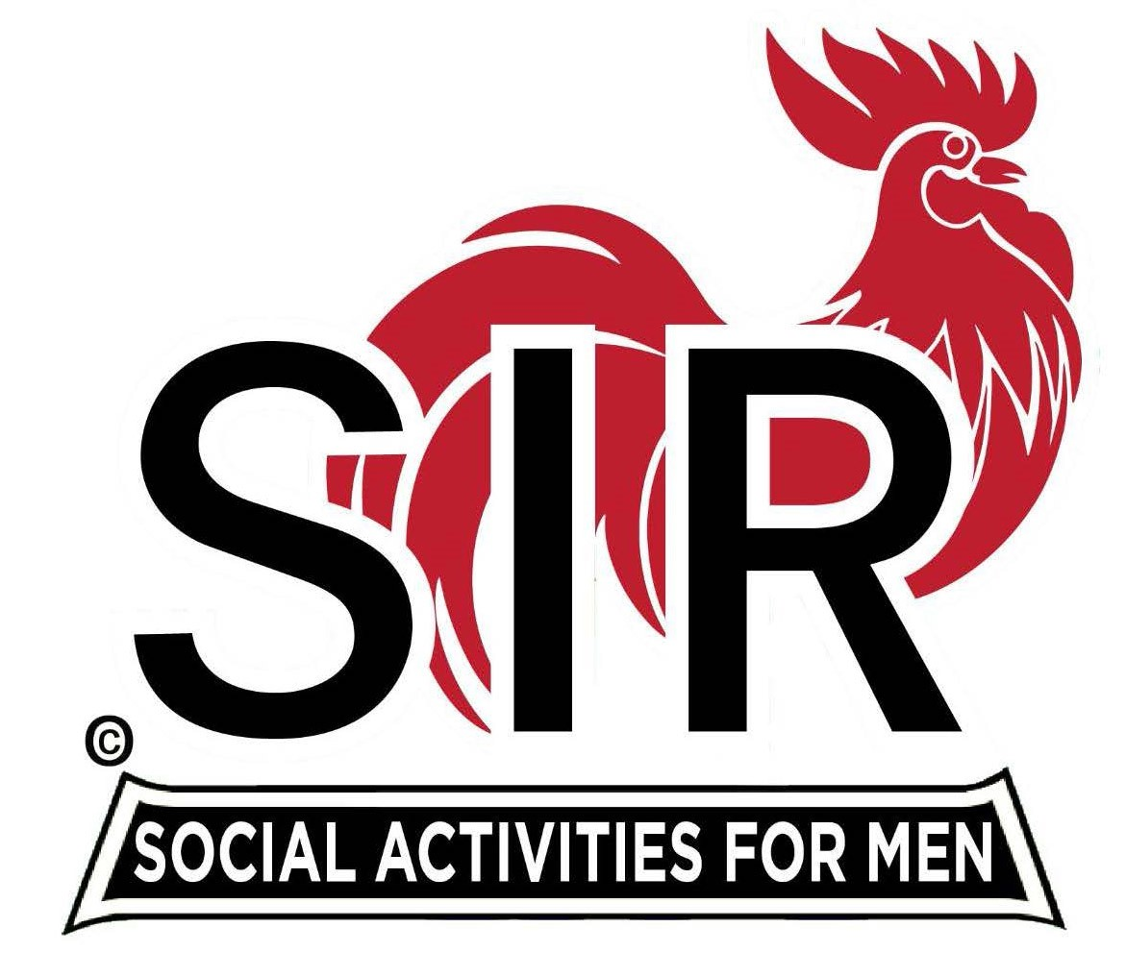
Las Trampas Branch 116
BEC Meeting Agenda
August 18th, 2025 - 9:15 AM at Boundary Oak
The Mission of SIR is to enhance the lives of our members through fun activities, events and luncheons while making friends for life.

09:15 | Call to order – Paul Russell  - Secretary - Dan Lawrence  - Confirm quorum  - Approval of July 21st 2025 BEC Meeting Minutes
09:20 | Standing Reports  - Treasurer Report – Charlie Guthrie  - Treasury Report  - Luncheon Count  - Big SIR Report – Paul Russell  - Ku Lee – sponsored by Frank Portillo  - Jim Byrns – sponsored by Brad Stribling  - Jeff Hamill – sponsored by Don Shroeder  - Greg Thornbury – sponsored by John Alonso  - Doug Janes – Former member of Branch 116 who left and came back.  - Membership – Phil Goff  - RAMP Department Head Reports  - Recruitment – Tending to family  - Activity Coordinator – Mike Ward  - Member Relations – Sam Beret  - Publicity – Allen Farbman  - Sunshine Committee – Dennis Snarr
9:50 | Little SIR Updates – Brad Stribling  - Speaker Info – Today’s speaker – Mr. Rick Jackson - short Bio  - Birthday Boys – August
9:55 | Updates & New Business  - Guests:  - Rod Maslowski – guest of Neil Schmidt  - Mark R. Clifford – guest of Bruce Lewis  - Nomination Committee (10 – 15 min)  - Carmel Golf Trip (5 min), USS Potomac (5 min)  - 3 Lunch requirement, will this be ongoing, short term? (discussion) what should we do about NON-EATERS.
10:15 | Adjourn: – Next meeting, September 15th, 2025  - Preparations - Lunch

